### **Sequence Diagram for News Aggregation System (NAS)**

The **Sequence Diagram** for the **News Aggregation System (NAS)** illustrates the sequence of interactions between users, system modules, and external components. It showcases how the system processes news articles, categorizes them, and presents them to users with features like filtering, sentiment analysis, and real-time updates.

### **Key Interactions:**

1. **News Collection:**
   * **User** (General Reader, Journalist, Researcher, etc.) requests news updates.
   * **NAS System** interacts with **News APIs**, **RSS Feeds**, and **Web Scraping Tools** to collect articles.
   * Articles are sent to the **News Collection Module** for processing.
2. **Headline Categorization:**
   * The **News Collection Module** sends articles to the **Headline Categorization Module**.
   * The **Headline Categorization Module** uses the **NLP Engine** to group articles under unified incident-based headlines.
   * Categorized articles are stored in the **Database**.
3. **Source Verification:**
   * The **Source Verification Module** checks the credibility of news sources.
   * Unreliable sources are flagged and verified articles are sent back to the **Database**.
4. **Filtering and Sorting:**
   * **User** applies filters (e.g., date, source, relevance) and sorting options (e.g., most recent, most relevant).
   * The **Filtering and Sorting Module** retrieves articles from the **Database** based on user preferences.
   * Filtered and sorted articles are displayed to the **User**.
5. **Real-Time Updates:**
   * The **Real-Time Updates Module** periodically checks for new articles from **News APIs** and **RSS Feeds**.
   * New articles are processed and categorized, then updated in the **Database**.
6. **Sentiment Analysis:**
   * The **Sentiment Analysis Module** analyses the sentiment of articles using the **NLP Engine**.
   * Sentiment scores are attached to articles and stored in the **Database**.
7. **Summary Generation:**
   * The **Summary Generation Module** generates concise summaries of articles using the **NLP Engine**.
   * Summaries are stored in the **Database** and displayed to the **User**.
8. **User Engagement:**
   * The **User Engagement Module** allows users to provide feedback, customize preferences, and interact with the system.
   * User interactions are logged in the **Database**.

### 

### **Sequence Diagram Description:**

1. **User Requests News:**
   * The **User** sends a request to the **NAS System** for news updates.
   * The **NAS System** triggers the **News Collection Module**.
2. **News Collection:**
   * The **News Collection Module** interacts with **News APIs**, **RSS Feeds**, and **Web Scraping Tools** to gather articles.
   * Articles are sent to the **Headline Categorization Module**.
3. **Headline Categorization:**
   * The **Headline Categorization Module** uses the **NLP Engine** to group articles under unified headlines.
   * Categorized articles are stored in the **Database**.
4. **Source Verification:**
   * The **Source Verification Module** checks the credibility of sources and flags unreliable ones.
   * Verified articles are stored in the **Database**.
5. **Filtering and Sorting:**
   * The **User** applies filters and sorting options.
   * The **Filtering and Sorting Module** retrieves articles from the **Database** and displays them to the **User**.
6. **Real-Time Updates:**
   * The **Real-Time Updates Module** periodically checks for new articles and updates the **Database**.
7. **Sentiment Analysis:**
   * The **Sentiment Analysis Module** analyses articles using the **NLP Engine** and attaches sentiment scores.
   * Sentiment scores are stored in the **Database**.
8. **Summary Generation:**
   * The **Summary Generation Module** generates summaries using the **NLP Engine**.
   * Summaries are stored in the **Database** and displayed to the **User**.
9. **User Engagement:**
   * The **User** interacts with the **User Engagement Module** to provide feedback and customize preferences.
   * Interactions are logged in the **Database**.

### 

### **Sequence Diagram (Detailed Model):**

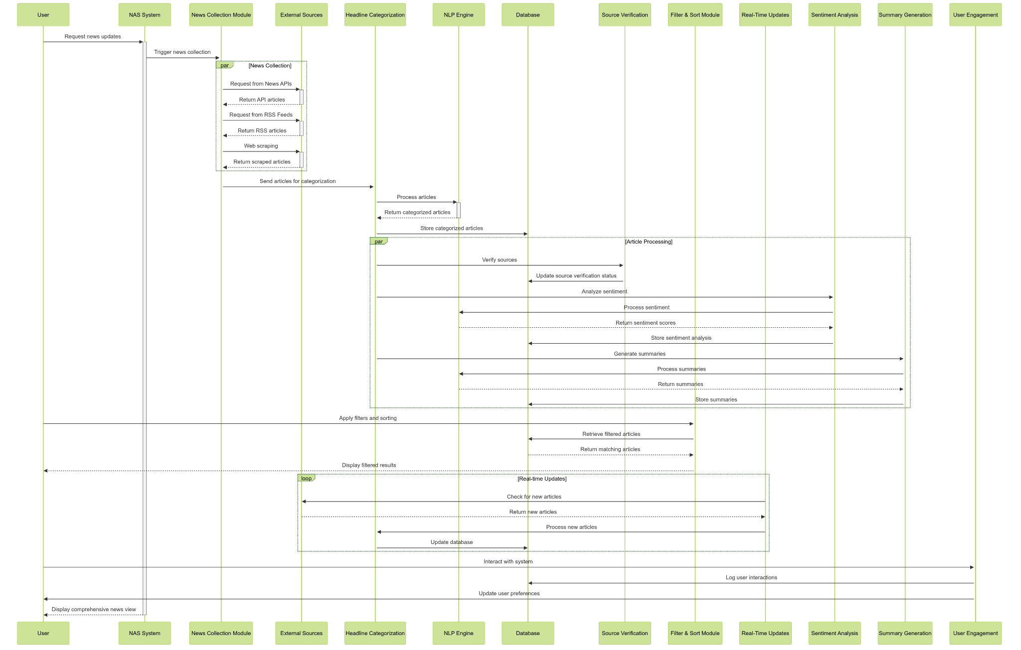

### **Visual Representation (Simplified):**

### 

This **Sequence Diagram** provides a clear and structured view of how the **News Aggregation System (NAS)** processes news articles, interacts with users, and delivers a seamless news consumption experience.